**Jenkins Release Jobs**

Build job configuration for gitlab release branch :

1.Project console view of release build job:

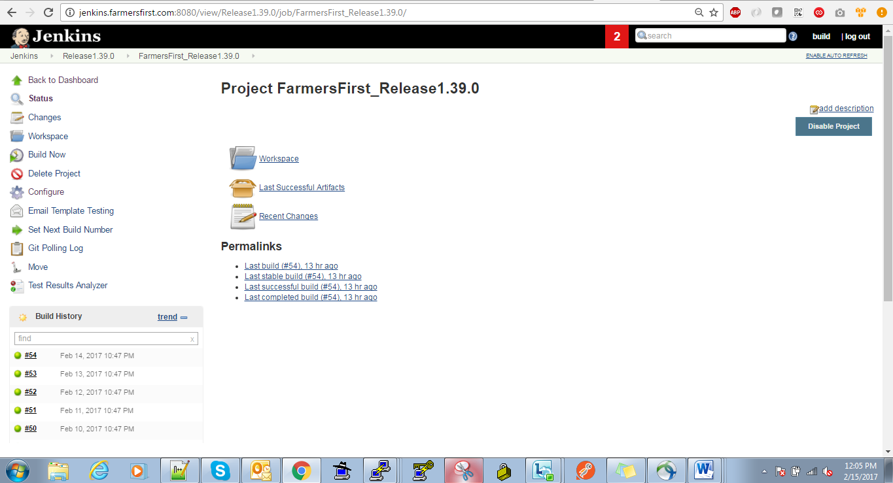

2.General configuration of release build Jenkins job:

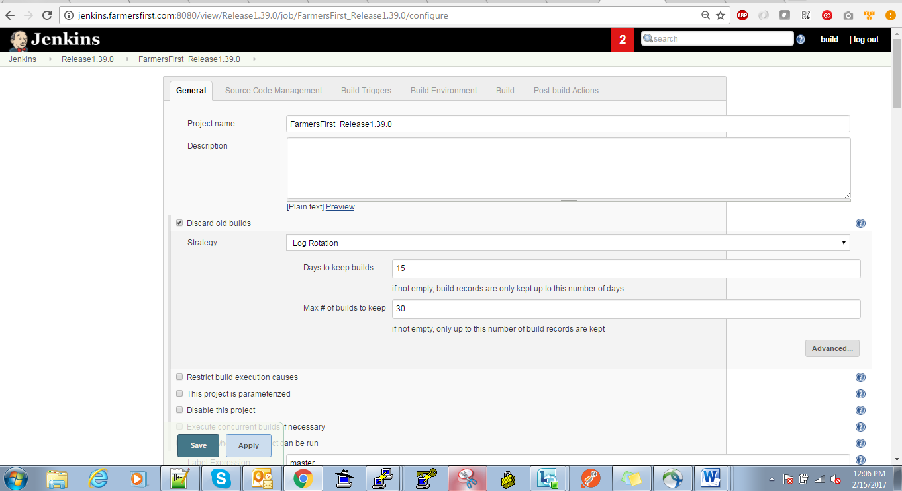

3.Source code (gitlab)pointing configuration:

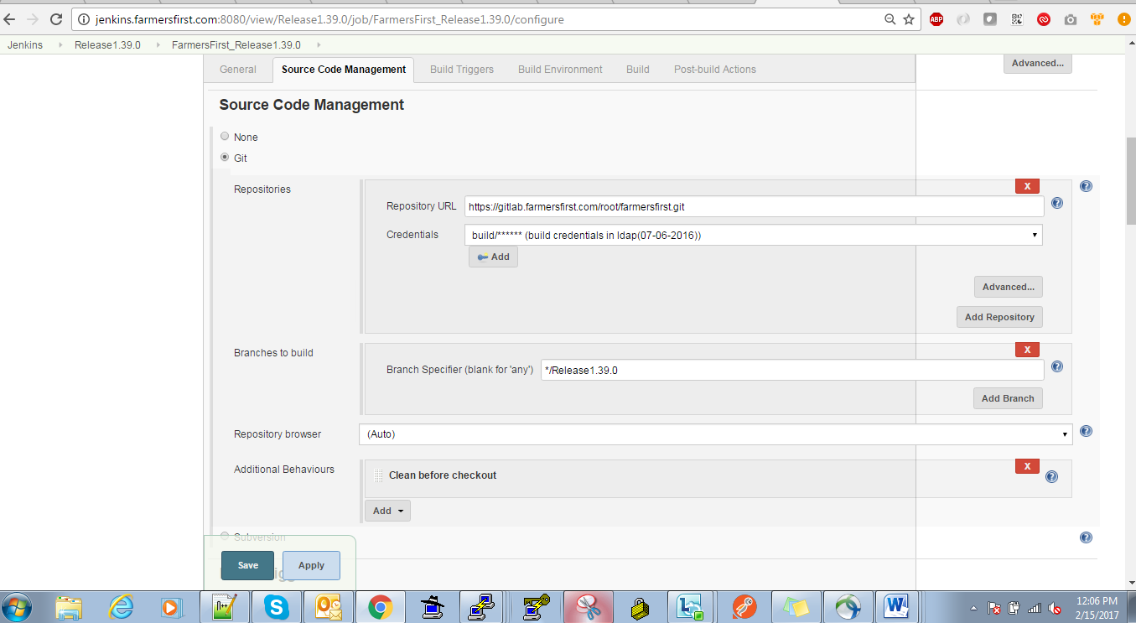

4.Build Triggers configuration:

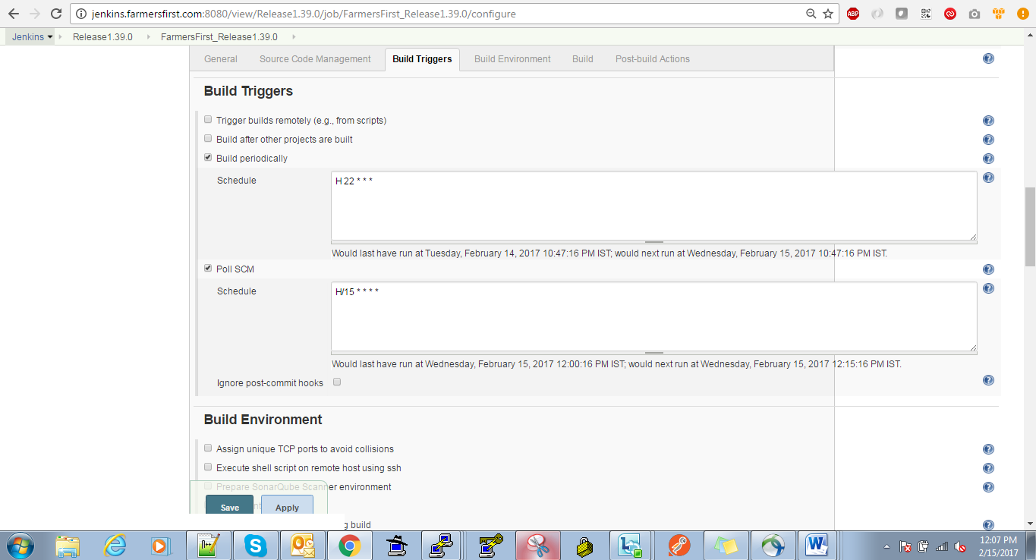

5.Build creation with maven and backup builds using aws s3 configuration:

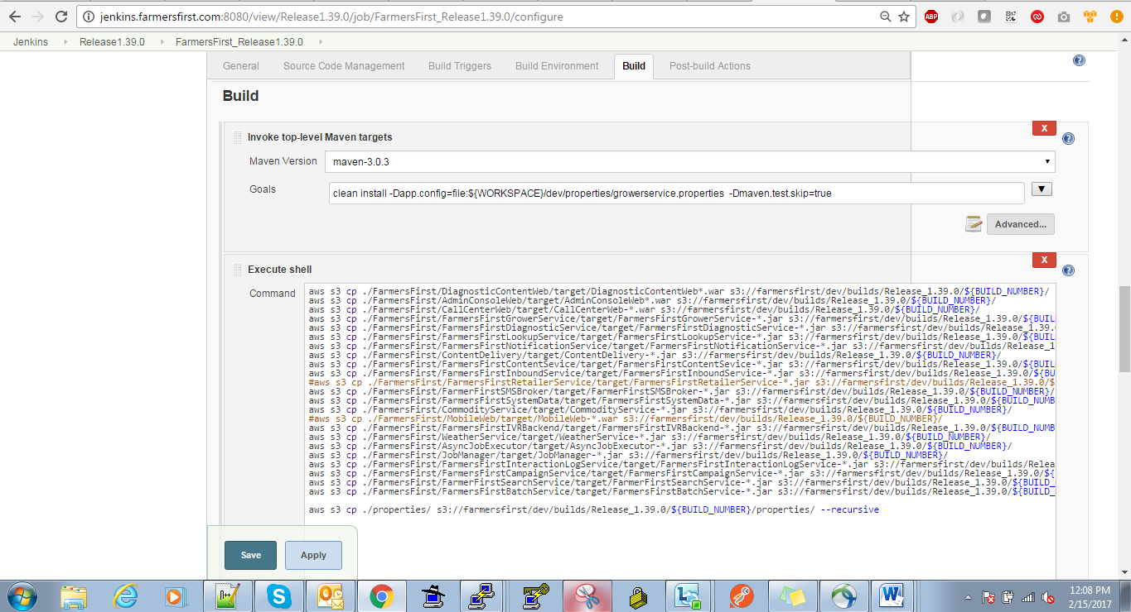

6.Post build Email trigger configuration:

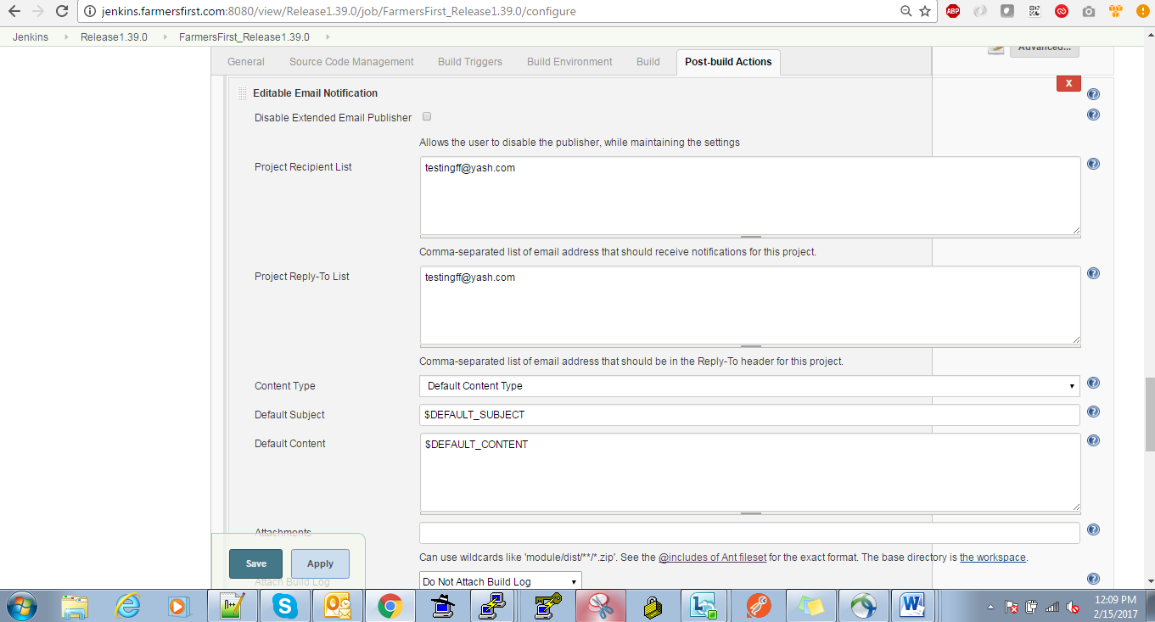

7.Triggering email notification before, after and failure of build configuration:

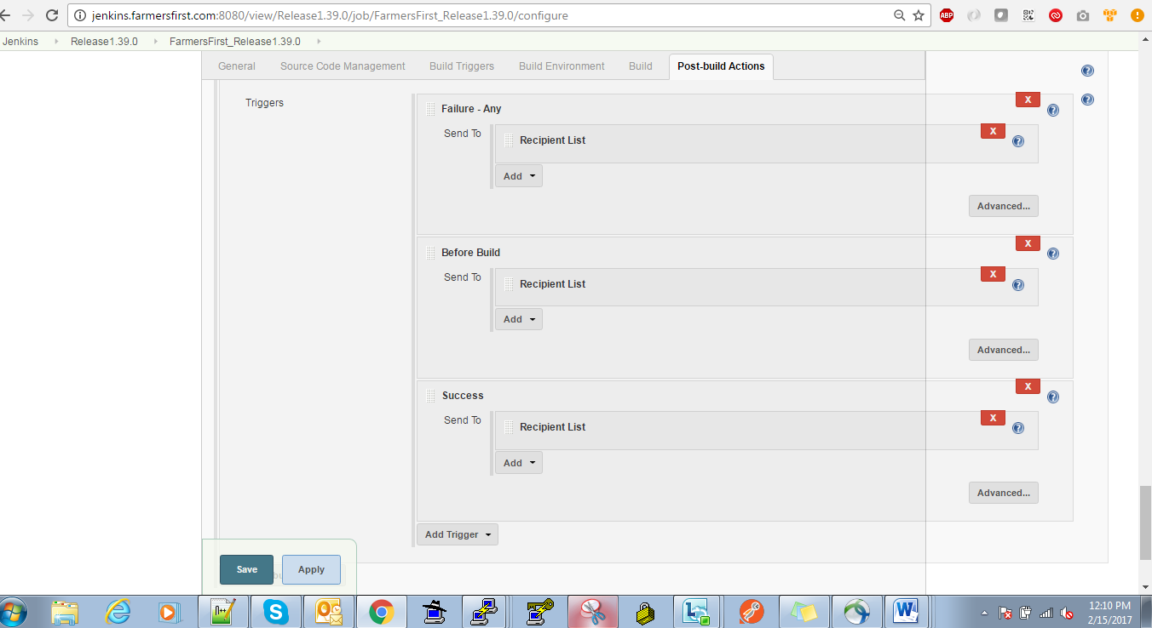

Deployment job configuration for gitlab release branch :

1.Project console view of release deployment job:

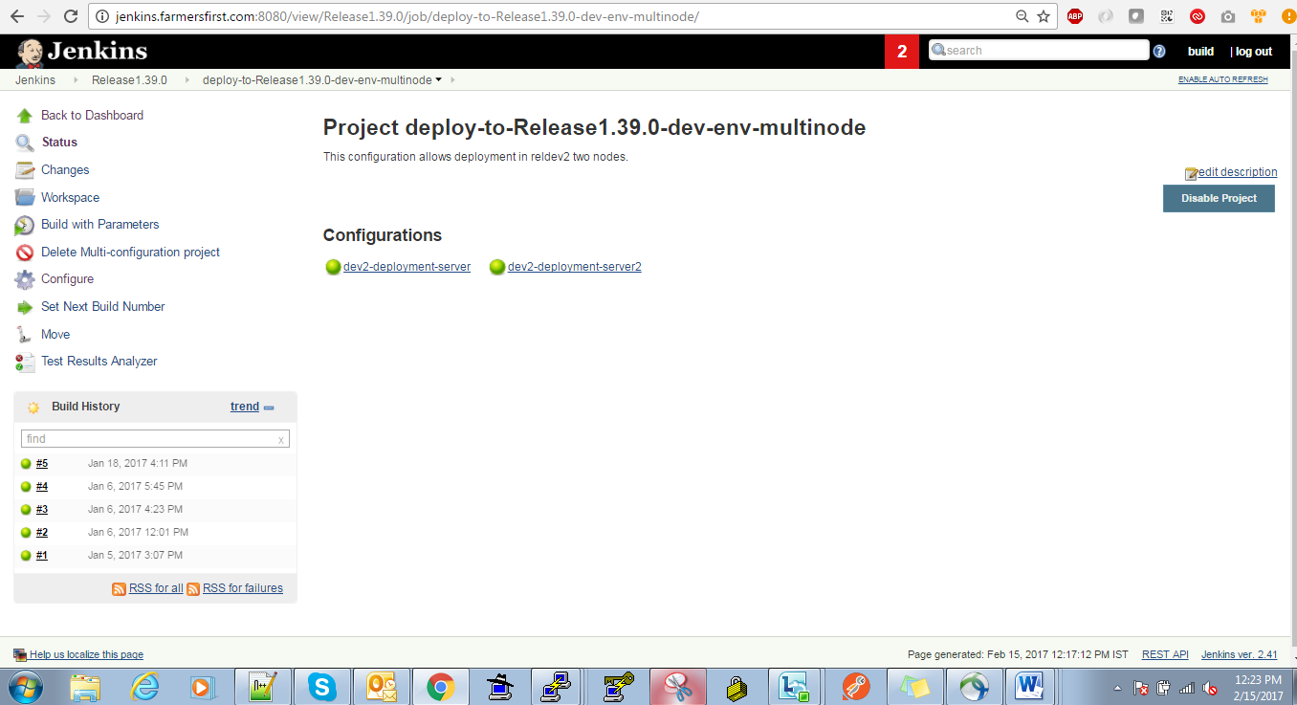

2.General configuration of release deploymentJenkins job:

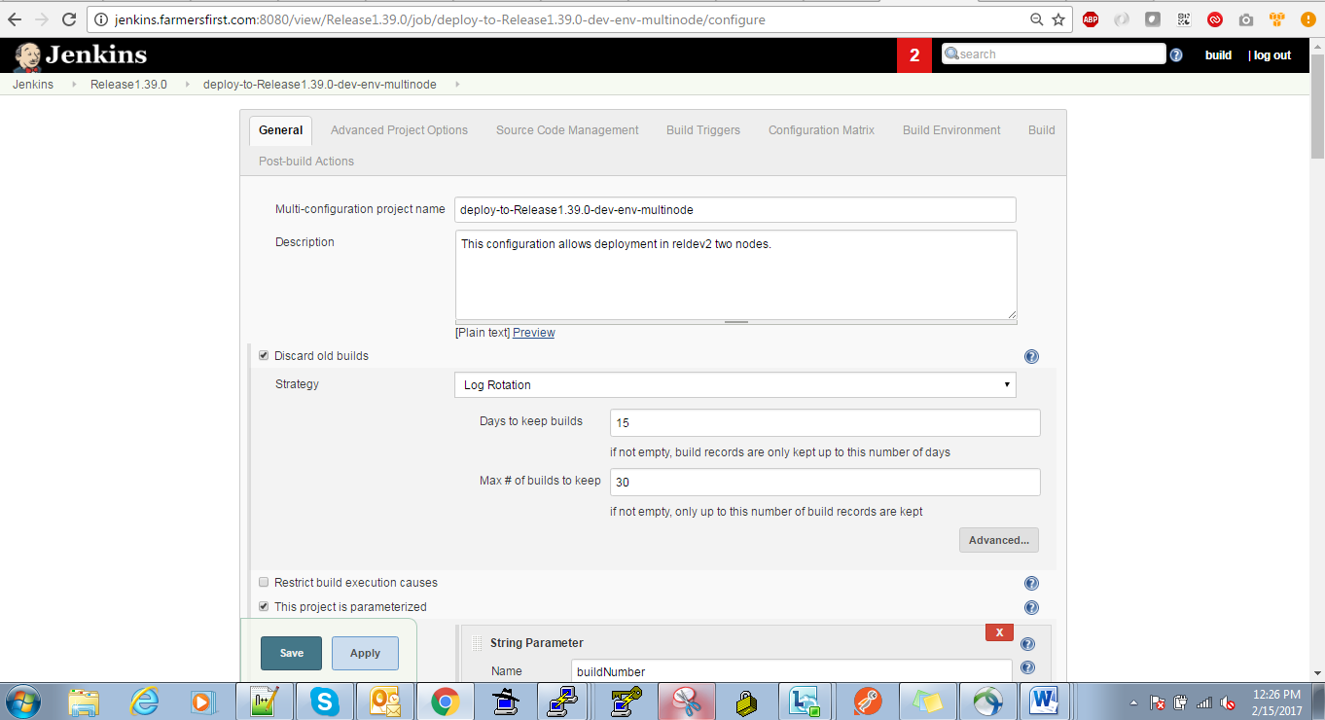

3.Deployment job configuration matrix :

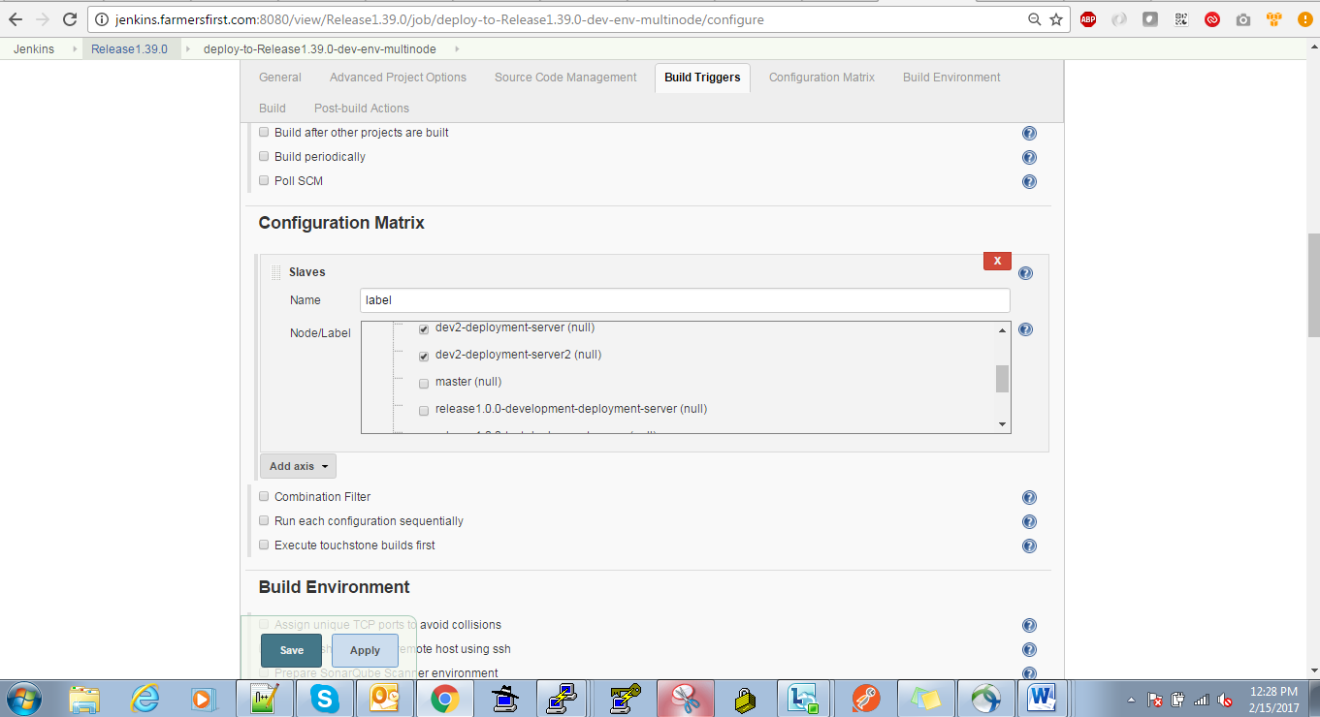

4.Build deployment configuration:

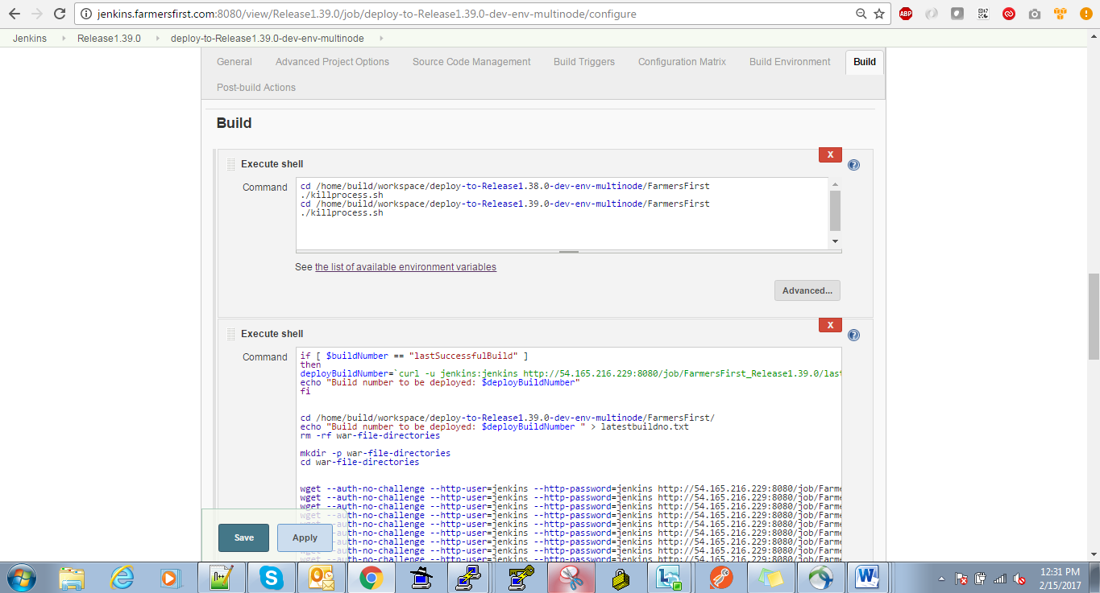

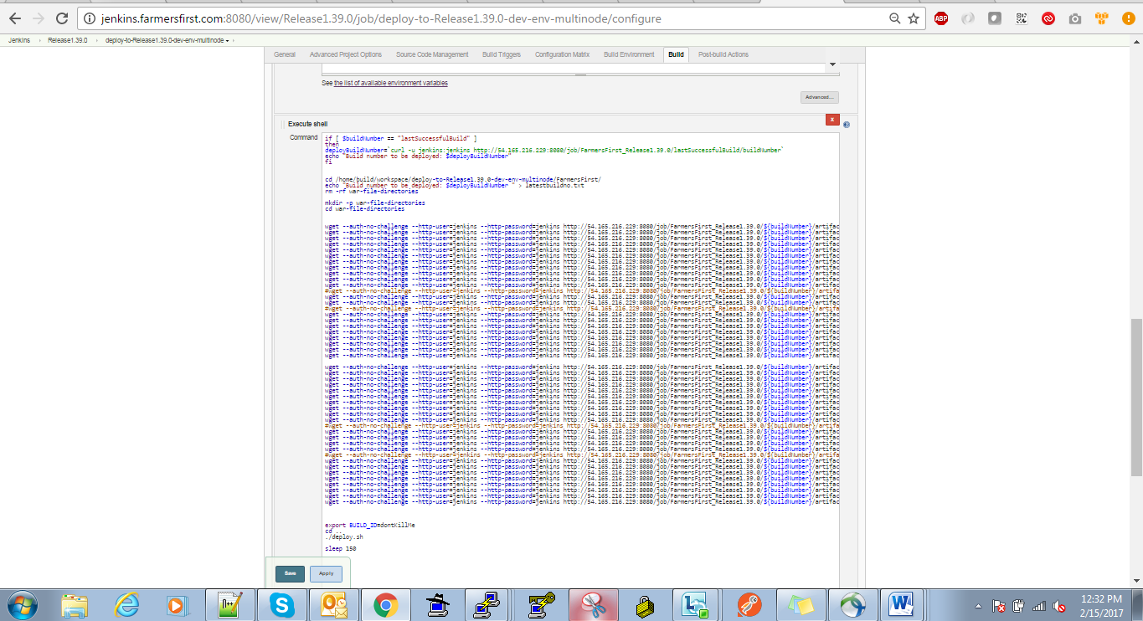

5.Post build configuration of the notification trigger

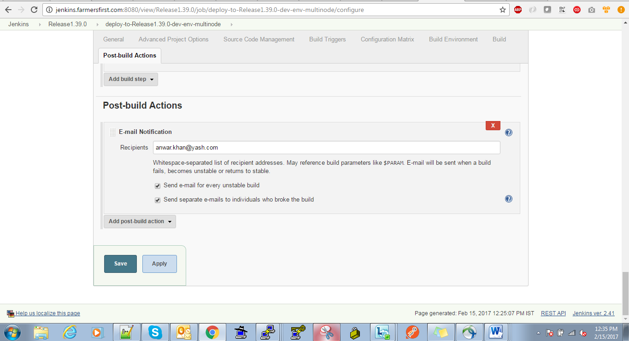

+++++++++++++++++++++++++++++++++++++++++++++++++++++++++++++++++++++++++++++++++++++

Ansible deployment configuration:

1.preprod(UI&API) deployment configuration with ansible

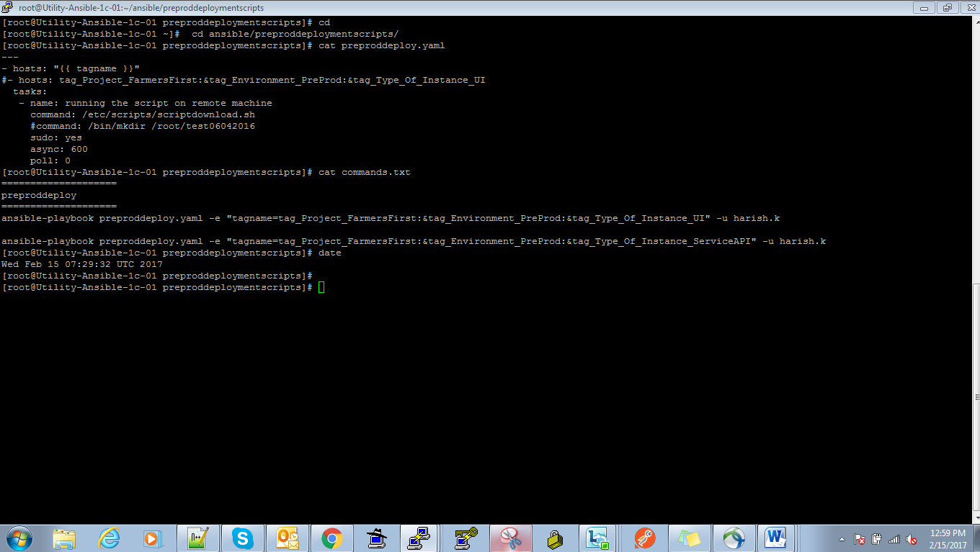

2. Prod(UI&API) deployment configuration with ansible

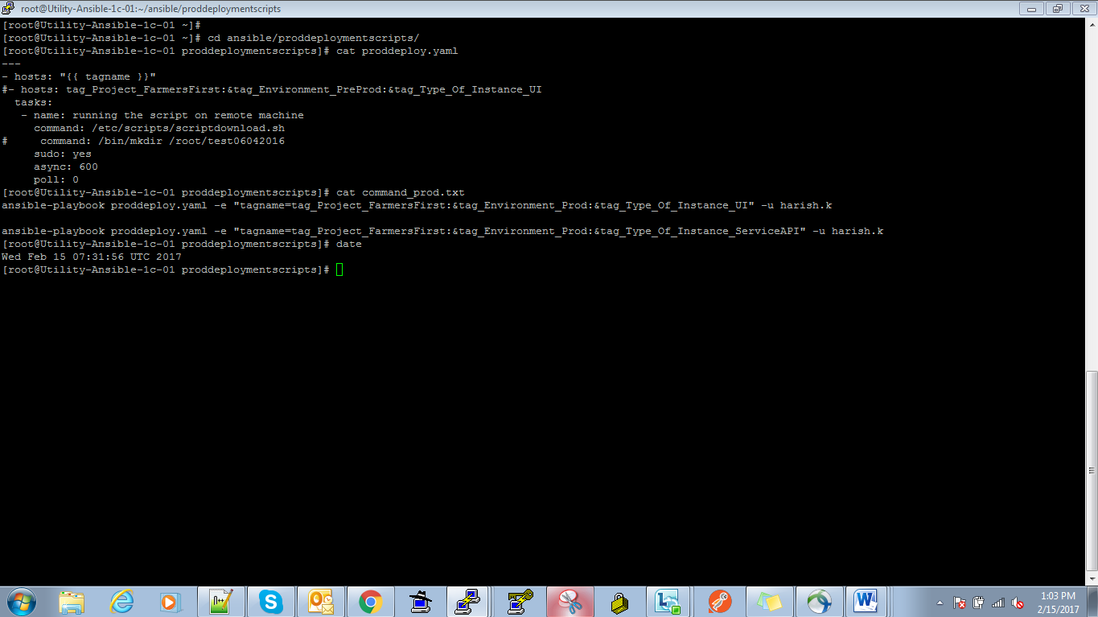

7) Screen shot of the logs stored in S3 logs - Infra, System, cloudtrail, application etc

Aws s3 logs of application and infra logs

1.preprod UI micro service logs:

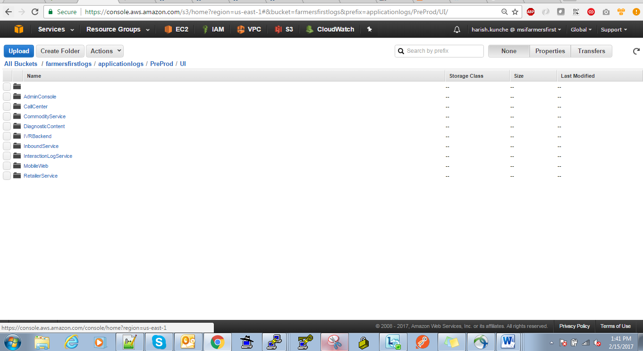

2.Preprod API microservice logs:

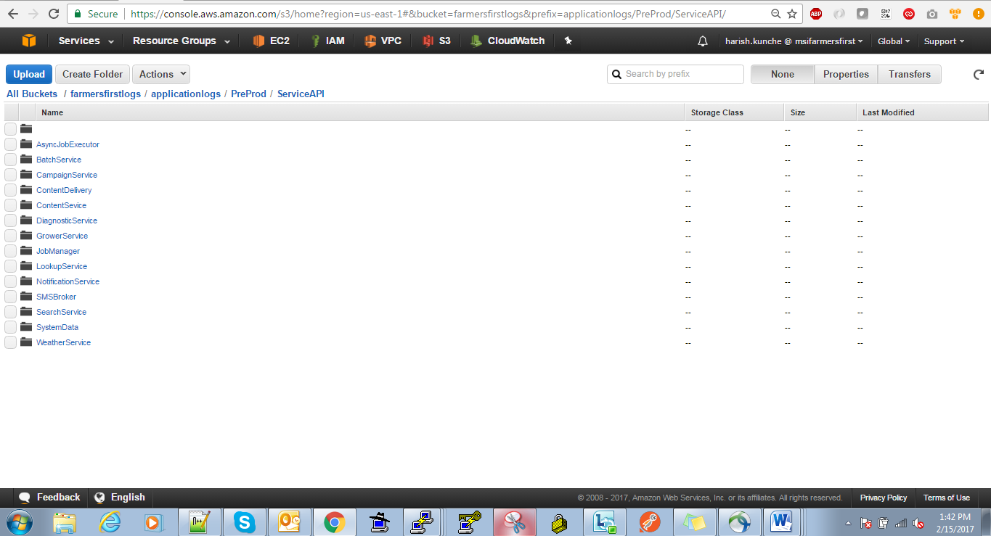

3.Infra logs backup in aws s3:

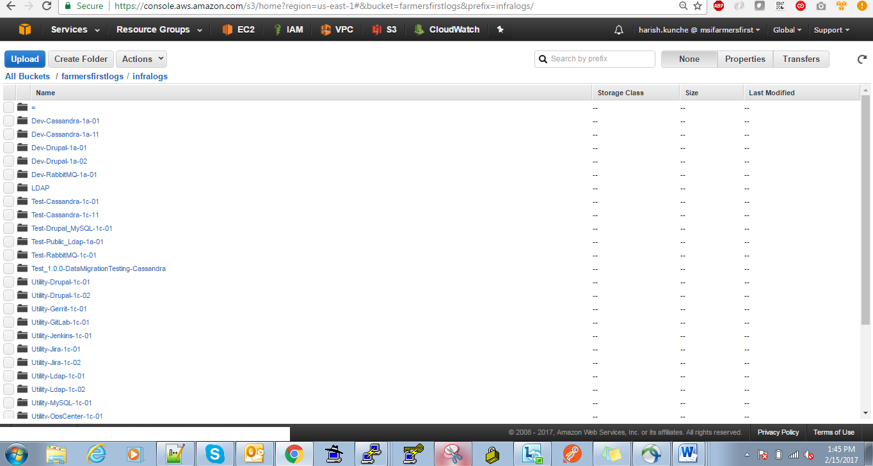

**4.Prod UI microservice logs :**

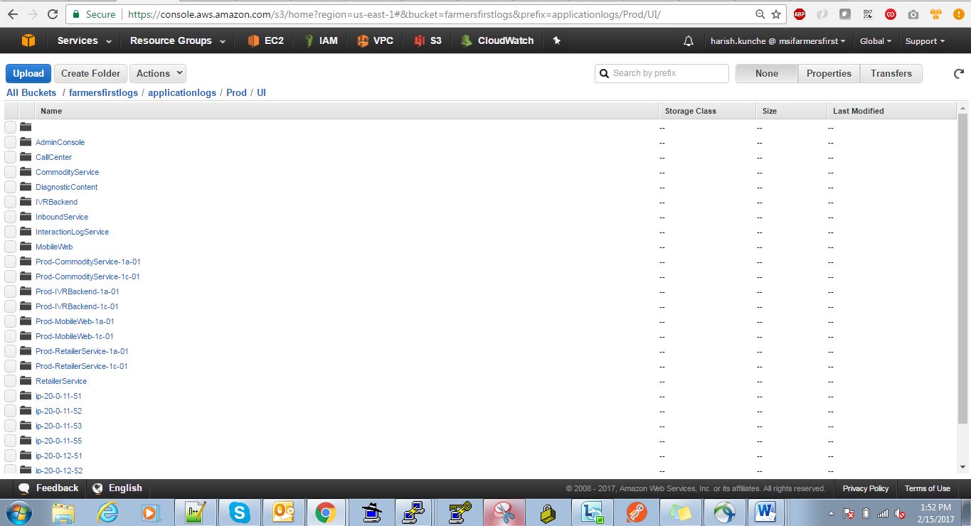

**5.Prod API microservice logs:**

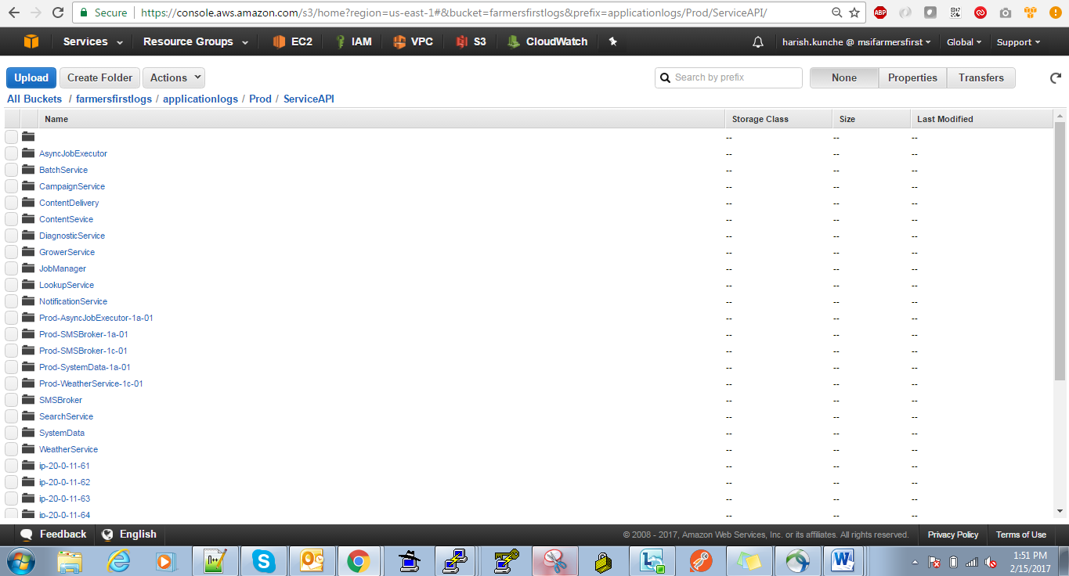

**6.preprod system logs in aws s3 backup:**

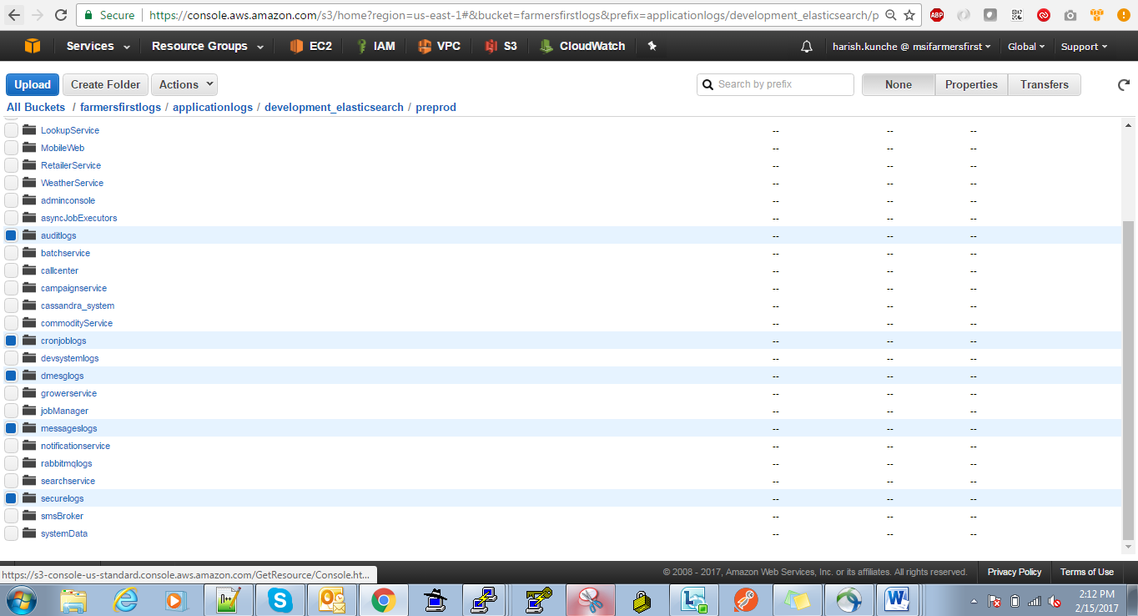

**7.Production System logs in aws s3 backup:**

